Jonne Avery Long
6527 NW Revere Drive
Kansas City MO 64151



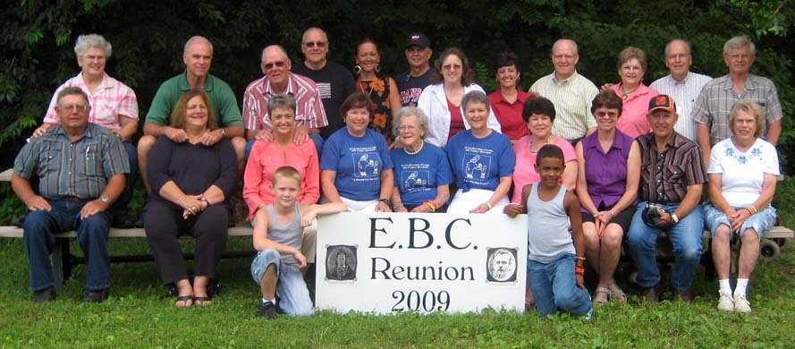
EBC Reunion 2012
We had fun in
Kansas in 2009→

Let’s do it

again this summer!

Please join us
at Tall Oaks

in Kansas

Friday, June 22 to Sunday, June 24, 2012
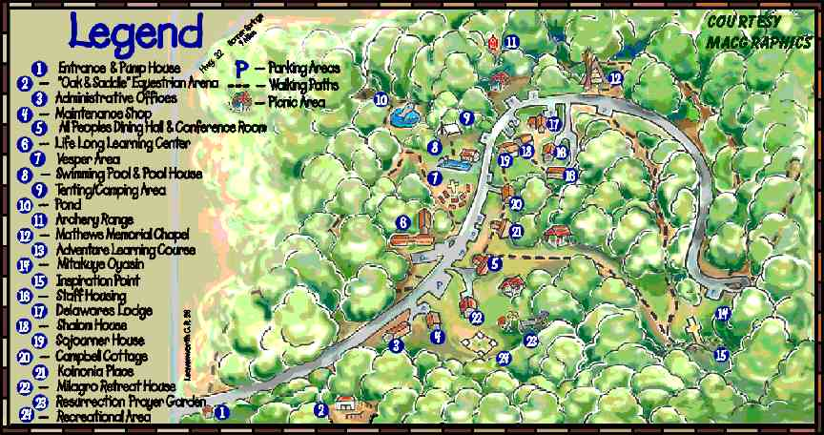
The 350 beautiful wooded acres
of Tall Oaks is halfway between the western edge of Kansas City
& the NE corner of Lawrence…
2 miles east of Linwood, Kansas
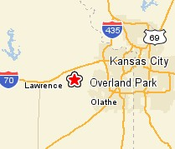
12th Triennial
v1a

Tall Oaks www.talloaks.org
Located on 350 beautiful woodland acres, Tall Oaks is only fifteen miles from both the western edge of Kansas City & the northeast corner of Lawrence, Kansas (two miles east
of Linwood, Kansas 66052). We selected this site for its relaxed setting & activities for kids.

Meals: All meals will be prepared for us (hooray!). Those on special diets may need
to bring their own food, although most (diabetic, vegetarians, etc) like the dining hall food.

Activities: Outdoor Swimming Pool • Horseback Riding • 5 miles of hiking and
horse trails • High, low and portable challenge • Unique outdoor chapels • Picnic area
with all traditional games • Nature program • Archery • Hayrides
Restrictions: No pets, alcohol, illegal drugs, firearms, fireworks or indoor smoking.

Rooms: The main building, LLC (Lifelong Learning Center), holds up to 48 people
in 12 motel-style rooms. Each room has 2 twin beds, a bunk bed, and a private bath,
and is designed to hold up to 4 persons. If some prefer 2 per room, we may also need
the Milagro cottage, which holds up to 16 persons in 4 similar-style rooms.

Rates: The price of the registration includes 2 overnights (Fri and Sat) plus 5 meals
(3 on Sat and 2 on Sun). Rates are charged by the number in each room. For example,
if 2 adults + 1 youth share a room, each would pay the triple rate according to their age.
Adult (18-up) Youth (5-17) Kids under 5
2 per room (each person) $160 $118 free
3 per room (each person) $143 $101 free
4 per room (each person) $139 $97 free

Registration for EBC 2012 Reunion at Tall Oaks near Linwood, Kansas 66052 • www.talloaks.org
Friday, June 22 to Sunday, June 24, 2012

Name & Address:
Names of persons planning to attend: Age Room with 2, 3, or 4 Any special needs?
1.
2.
3.
Write additional names on a separate sheet of paper.

Swimming, hiking and picnic area with traditional games are free, but need to be reserved 30 days in advance. Please indicate if anyone in your family is interested in the following free activities (mark all that apply).
___ Swimming ___ Hiking ___ Games: __ horseshoes __ softball __ sand volleyball __ croquet
__ basketball __ soccer __ other________________________
Please indicate how many are interested in the following paid activities. Amounts are per person; minimum numbers are required.
___$14 Horseback trail ride ___$7 Horseback lead line ___$4 Wagon ride & s’mores
12 yrs & up (min. 8) 5-11 yrs All ages (min. 10)

Return form by Tuesday, May 1 to: Gwen Eidman • 2650 215th Rd. • Emporia, KS 66801
Please help us count! Do let us know as soon as you decide to come. Also, if you know how many are coming and your preferences. Tall Oaks is a popular summer retreat, so we must let them know the size of our group.
Make your checks payable to EBC Reunion. (The EBC treasurer will make group payment to Tall Oaks).
Detach and return form below to Gwen Eidman by Tuesday, May 1, 2012

[Detach and send] - - - - - - - - - - - - - - - - - - - - - - - - - - - - - - - - - - - - - - - - - - - - - - - - - - - - - - - - -
For updates & information, visit the website:
www.EBCReunion.org

or call or email the Reunion Committee:
Gwen Eidman 620-343-1473 geidman@hotmail.com
Laura Kampshroeder 913-888-6606 kamps1968@gmail.com
Randy Sharp 501-442-7489 rnsharp06@sbcglobal.net
Jonne Long 816-741-9293 jlong14@kc.rr.com
Earl Visser 402-730-1075 earl_visser@yahoo.com
Cheri Black 215-882-4351 cblack7020@gmail.com
Kriss Avery 314-298-0297 kriss@rainbowsound.us
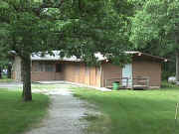
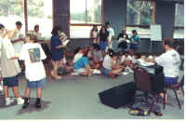
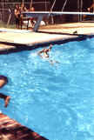
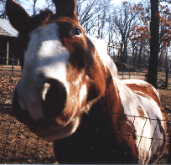
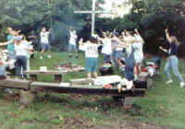
If you have questions about Tall Oaks, contact any member of the Reunion Committee, or the Tall Oaks Director, Sharon at sharon@talloaks.org or 800-617-1484.
Our Treasurer, Gwen Eidman, will coordinate the EBC REUNION GROUP reservation.

